Police Complaint Management System using Blockchain Technology

Earlier all criminal records were maintained in a register which can be easily manipulated and time consuming process to transfer register data from one police station to other station. To overcome from above issue Online Criminal Tracking System was introduced which is managed by a single centralized servers, if this server is down then criminal tracking services will get disturbed and internal employee of server management can be manipulated easily and those manipulation cannot be detected easily.

To overcome from above issue author of this paper proposing concept to migrate single centralized criminal tracking system to Blockchain based distributed system. Blockchain has inbuilt support for distributed data management and data verification which will not allow anybody to manipulate any records and all data stored in Blockchain are encrypted.

Blockchain stored data at multiple nodes as distributed servers and if one node down then data can be access from other working nodes. Blockchain store each record as Block/Transaction and associate each block with unique hash code and before storing any new data Blockchain will verify hashcode of old Blocks and if data not alter then same hashcode will be generated and verification get successful and if data alter then it will result into different hashcode and verification get failed and data tamper will get detected.

So by employing Blockchain technology we can overcome from all disadvantages faces during single centralized servers.

Blockchain utilize SOLODITY programs called ‘Smart Contract’ to allow users to call those functions to store or retrieve data from Blockchain. In below screen we are showing SOLIDITY code to access data from Blockchain

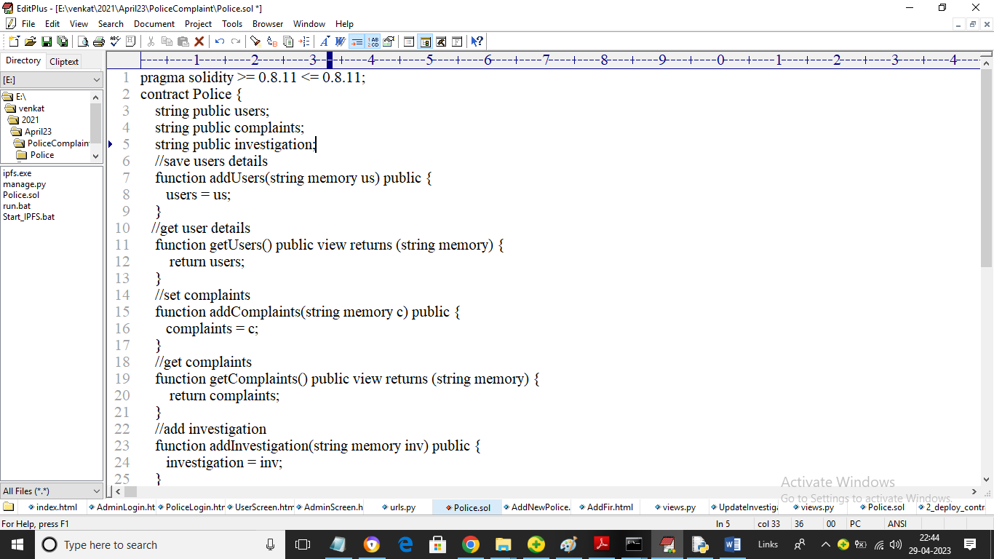

In above SOLIDITY code we have functions to save and get users, complaints and investigation details and now we need to deploy this code in Blockchain by using below steps

1. First go inside ‘hello-eth/node-modules/bin’ folder and then find ‘runBlockchain.bat’ file from same folder and then double click on it to get below screen
2. 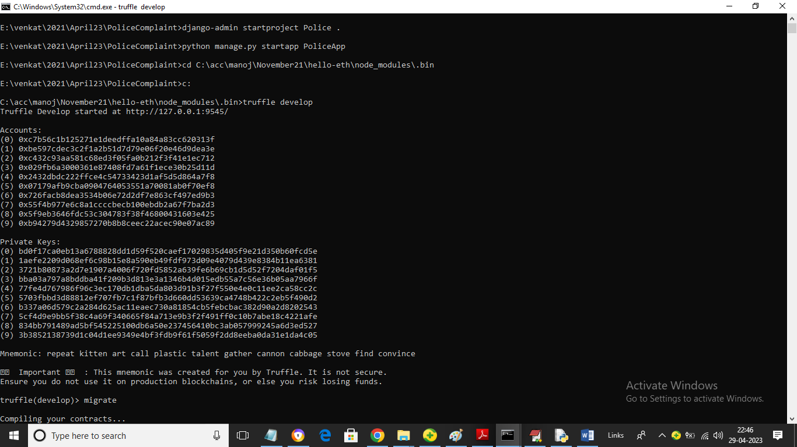
3. In above screen Blockchain server started with default accounts and private keys and then enter command as ‘migrate’ and then press enter key to get below page
4. 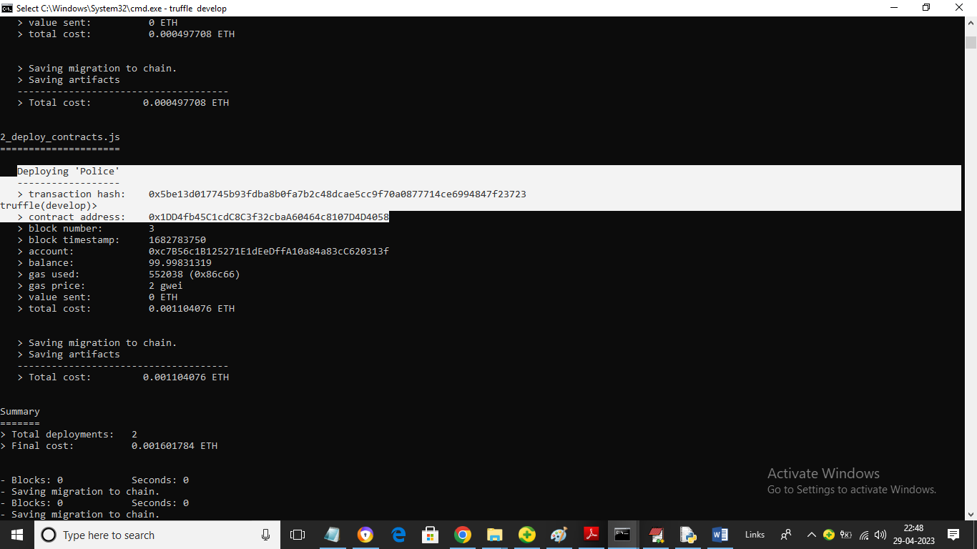
5. In above screen in white colour text we can see ‘Police’ contract deployed in Blockchain and we got contract address also and this address we need to specify that address in PYTHON code to access and store data in Blockchain and in below screen we can see python code calling Smart Contract code from Blockchain
6. 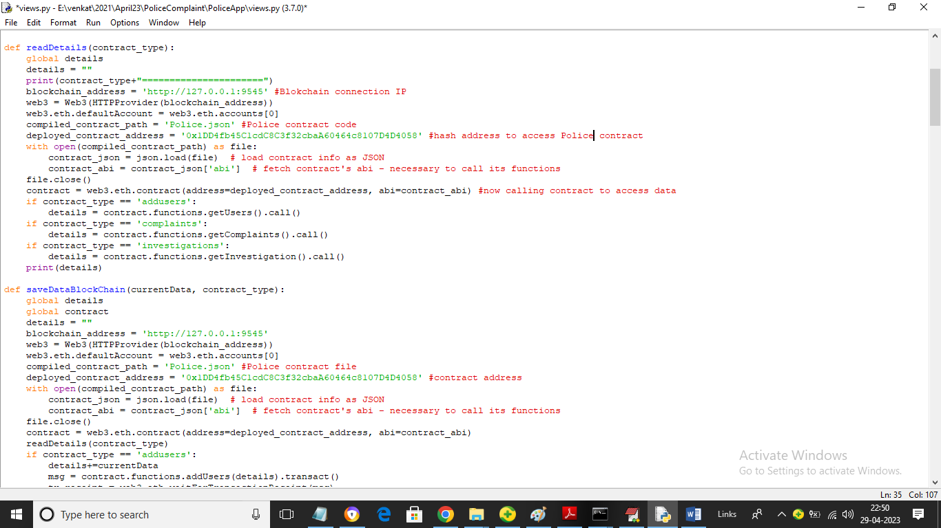
7. In above python code read red colour comments to know about contract calling using python. Now let above server running.

To implement this project we have designed following modules

1. Admin: admin can login to application using username and password as ‘admin’ and ‘admin’. After login admin will add Police employees and then give username and password to each police personnel. Admin can view all added police personnel and can view all investigations reports.
2. Police: police can login to application using username and password given by admin and then add new FIR and can add updated investigations and all other police station peoples can view all FIR and updated investigations.

All documents and images uploaded to Blockchain will get saved inside IPFS server as Blockchain designed to stored simple transaction data not documents so IPFS will stored document and give document storage address as hashcode and this hashcode will get saved inside Blockchain and later Blockchain will use this hashcode to download files.

SCREEN SHOTS

To run project double click on ‘Start_IPFS.bat’ file to start IPFS server and get below output

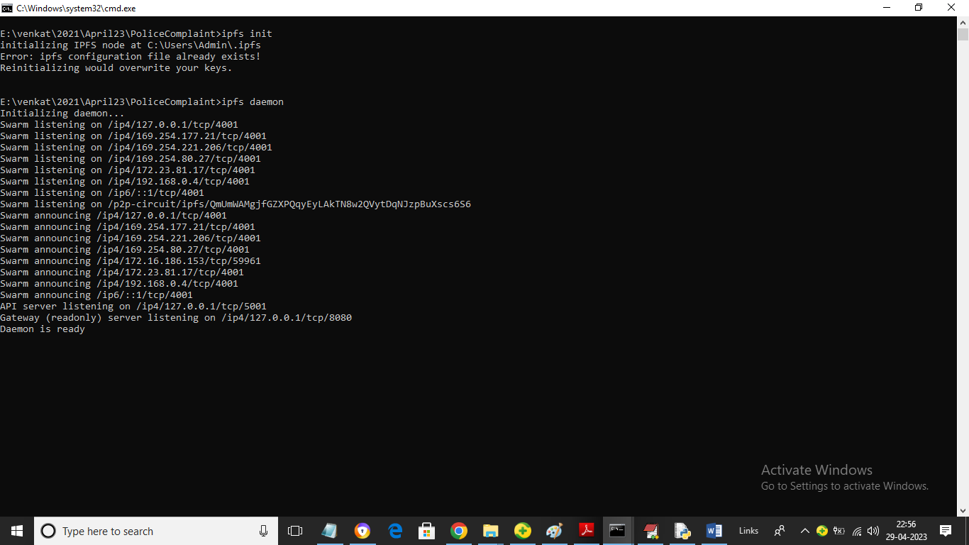

In above screen IPFS server started and now double click on ‘run.bat’ to start python WEB SERVER and get below page

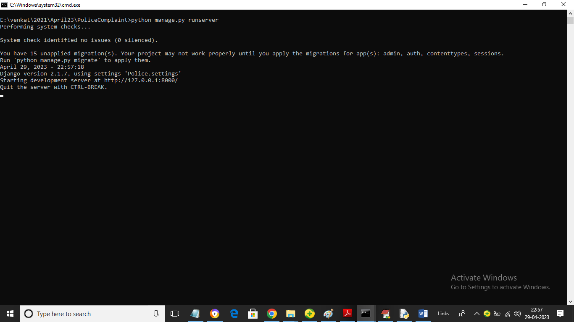

In above screen python web server started and now open browser and enter URL as <http://127.0.0.1:8000/index.html> and press enter key to get below page

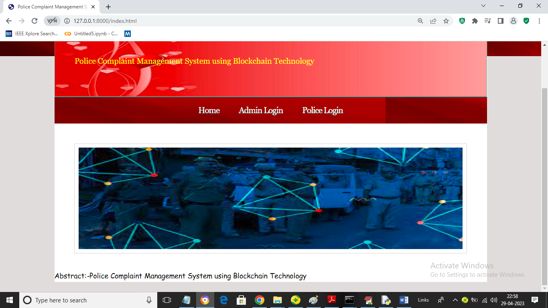

In above screen click on ‘Admin Login’ link to get below login screen

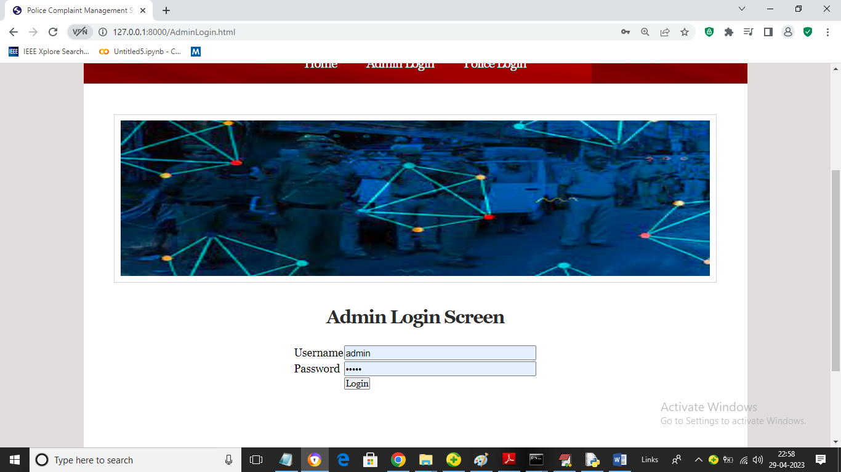

In above screen admin is login and after login will get below page

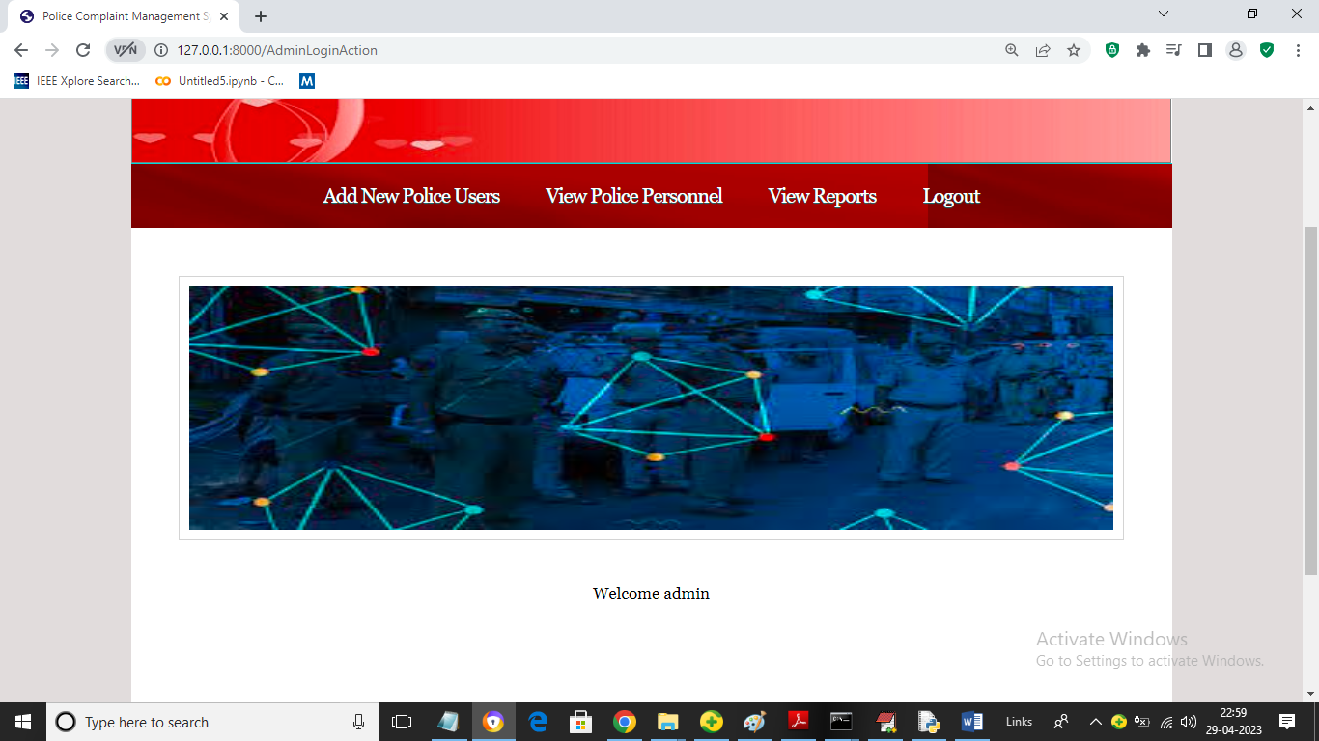

In above screen admin can click on ‘Add New Police Users’ link to get below page

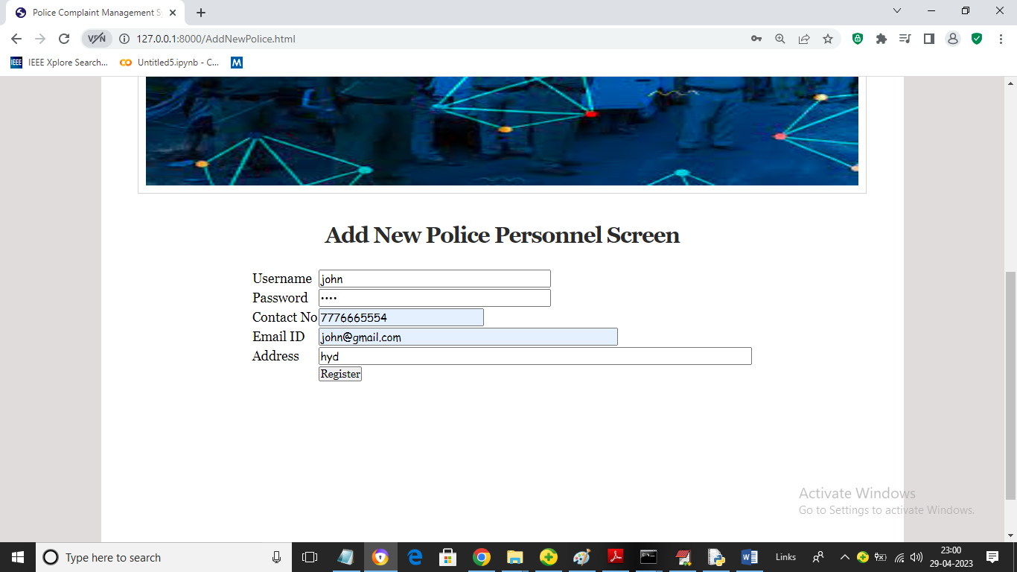

In above screen admin will add new Police personnel details and then give this login details to police personnel to add FIR details

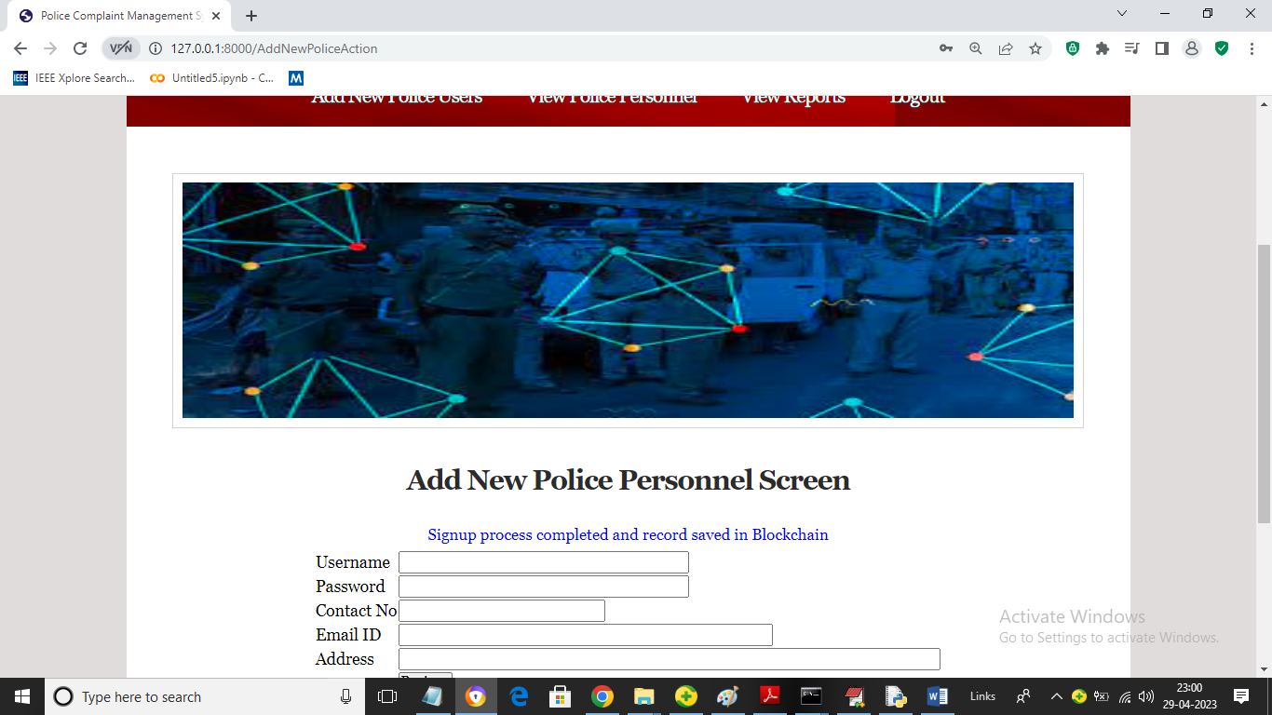

In above screen police details added in Blockchain and now click on ‘View Police Personnel’ link to view all available police men details

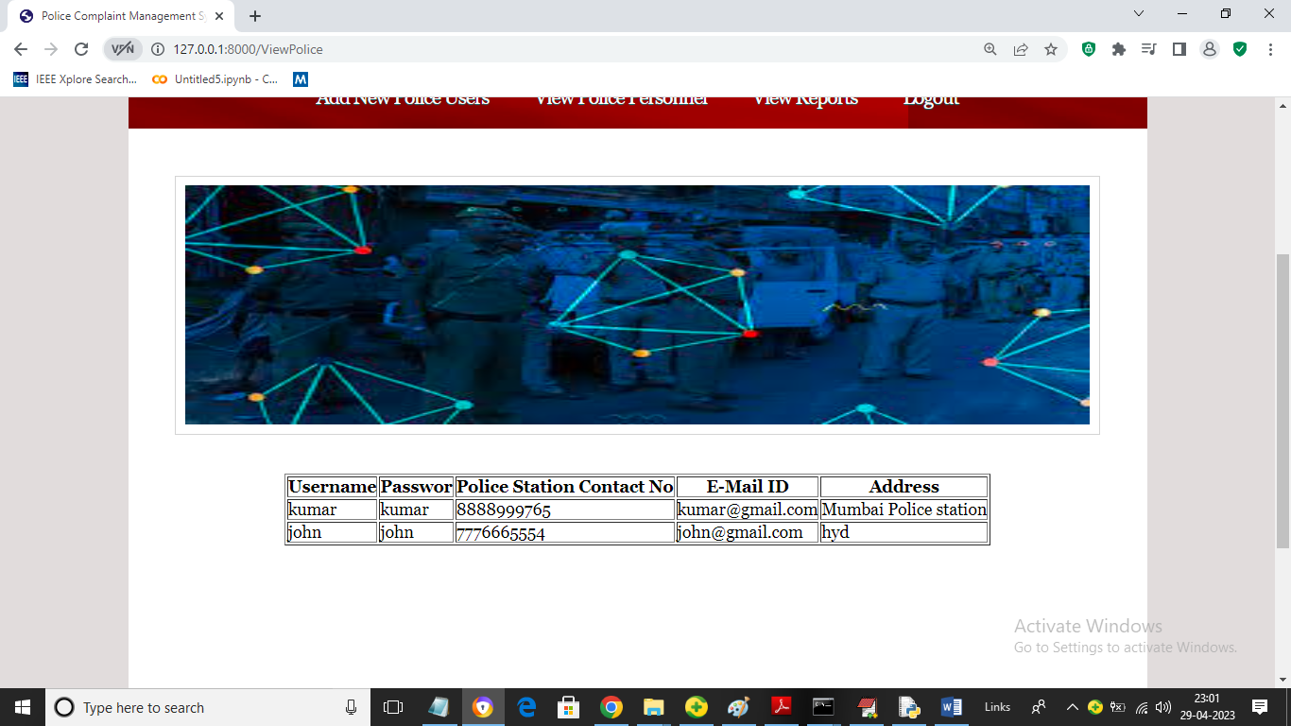

In above screen admin can view all police details and now click on ‘View Reports’ link to view all existing FIR reports and investigations

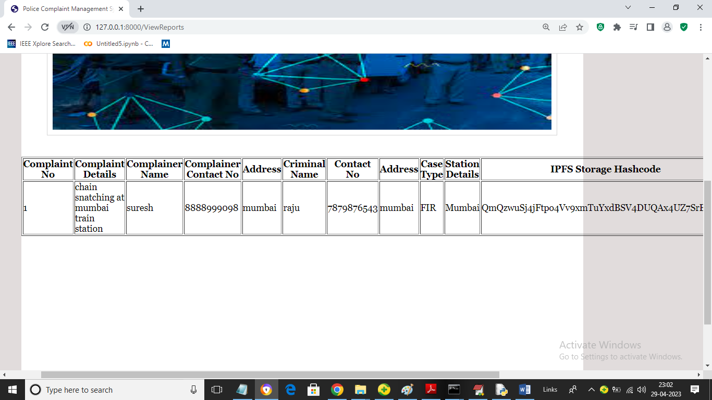

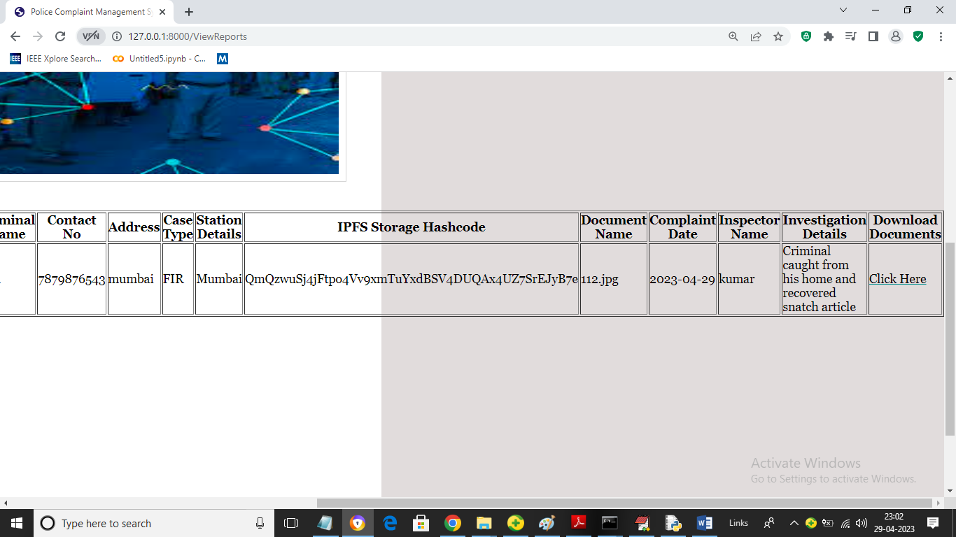

In above two screen admin can view all previously added FIR reports and can click on ‘Click Here’ link to download all crime related report and this report will saved in Blockchain in encrypted format. Now logout and login as Police personnel

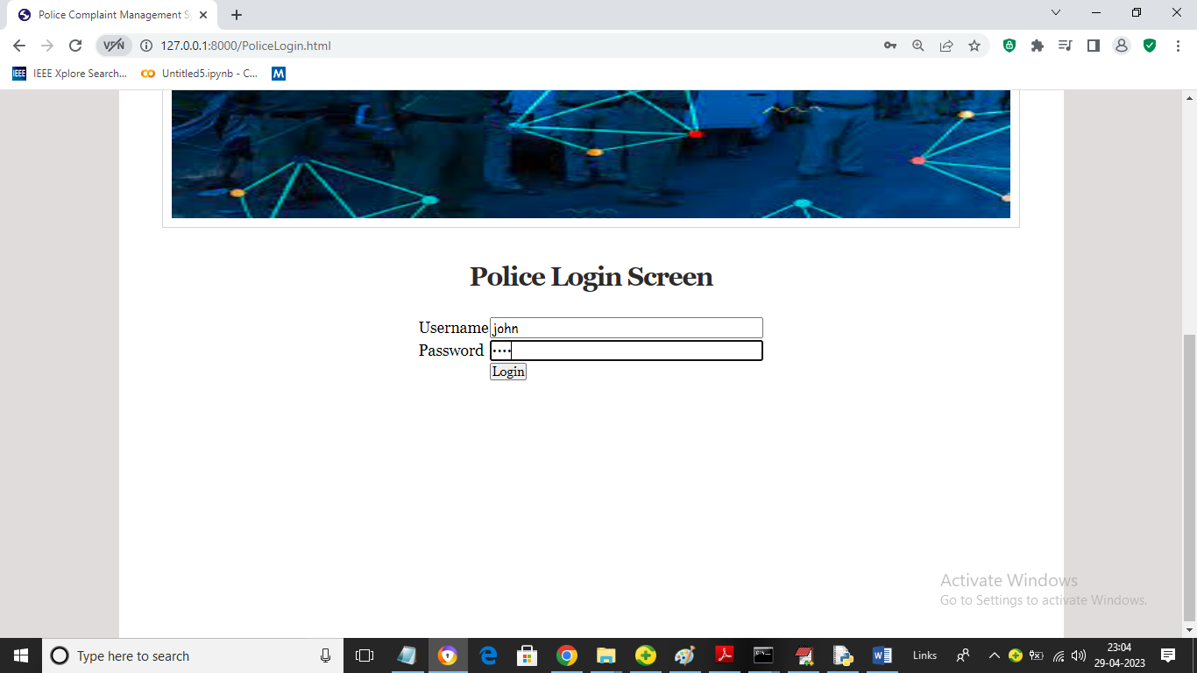

In above screen police personnel is login and after login will get below page

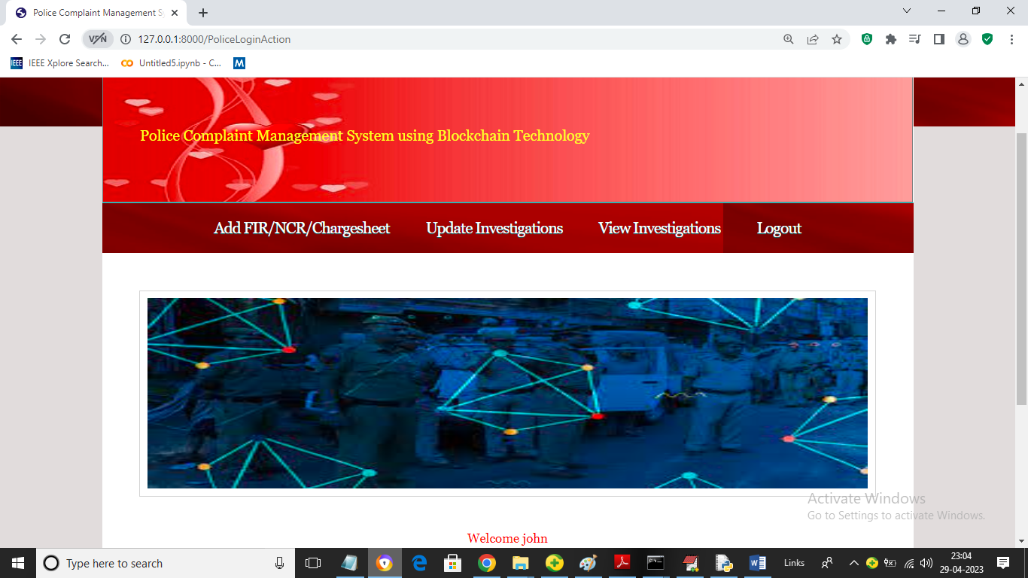

In above screen police can click on ‘Add FIR/NCR/Charge sheet’ link to add FIR

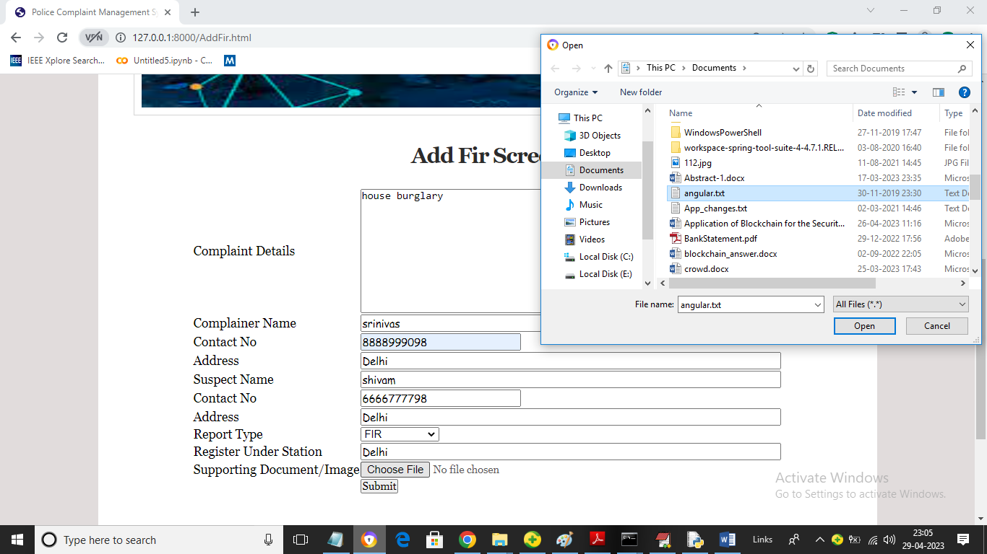

In above screen police user can add all Crime details as FIR and then upload crime related file and then click on ‘Open’ and ‘Submit’ button to get below output

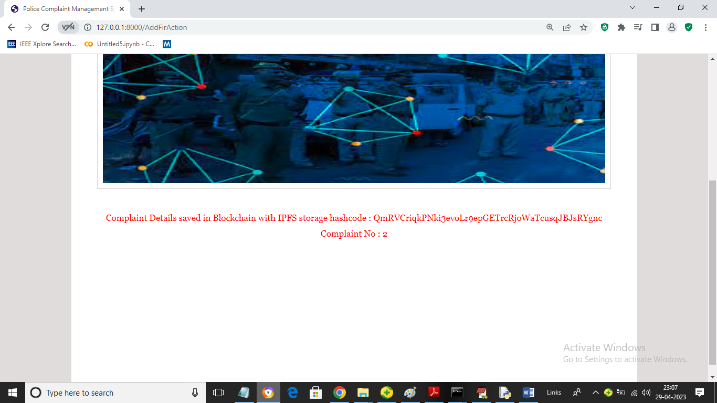

In above screen complaints details added to Blockchain and file get saved in IPFS and now police can click on ‘Update Investigation’ link to add future investigation data to current FIR like below page

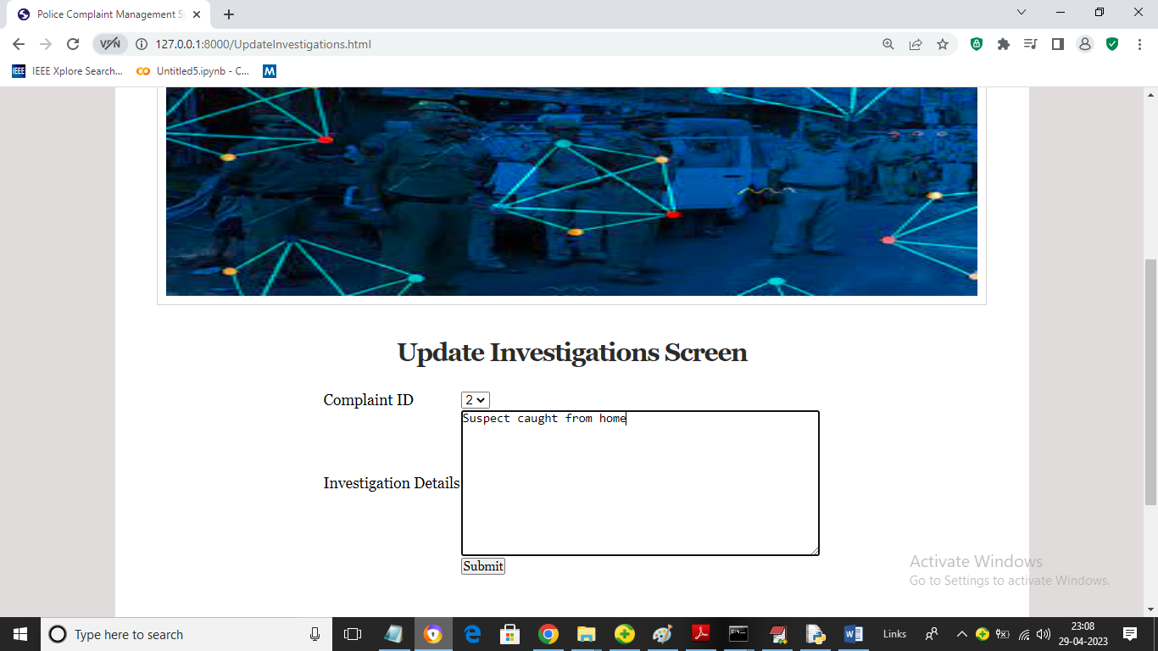

In above screen police will select complaint number and then add investigation data and then press button to save data in Blockchain and then will get below page

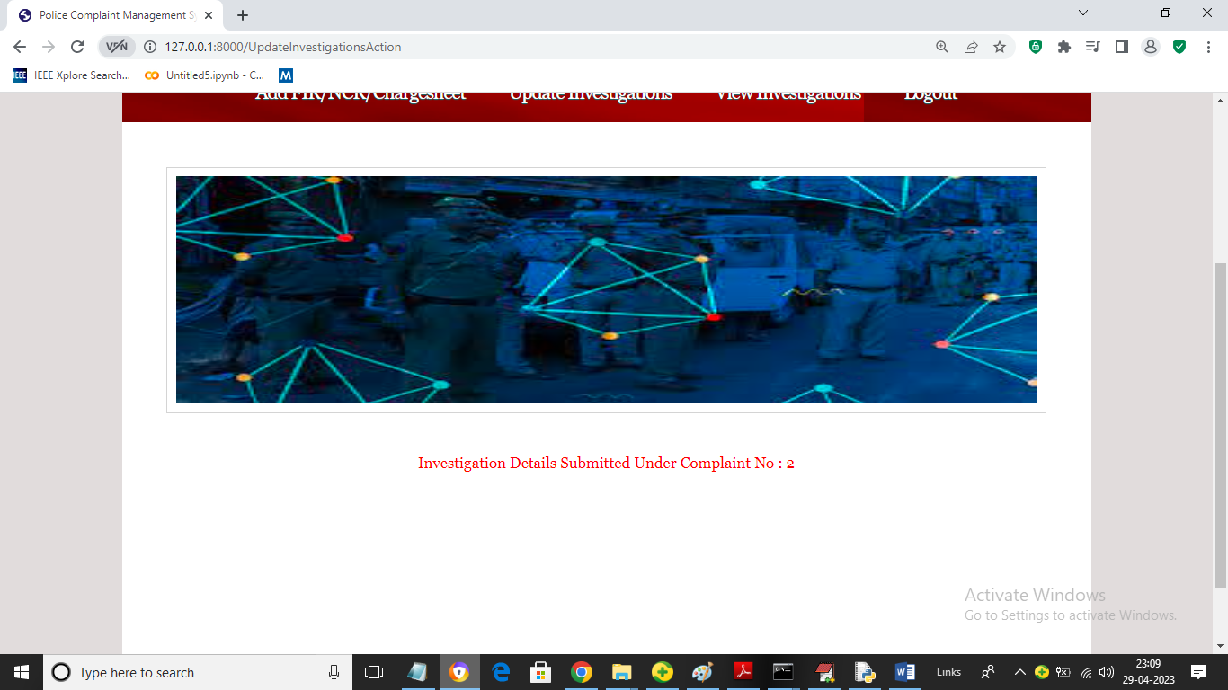

In above screen we can see investigation details updated and now click on ‘View Investigation’ link to get below investigated and complaint details from Blockchain

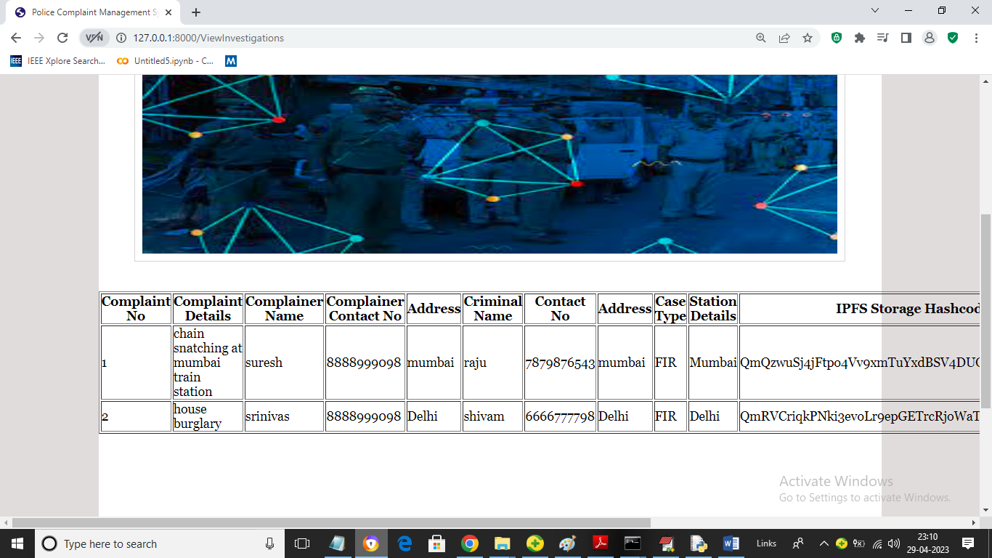

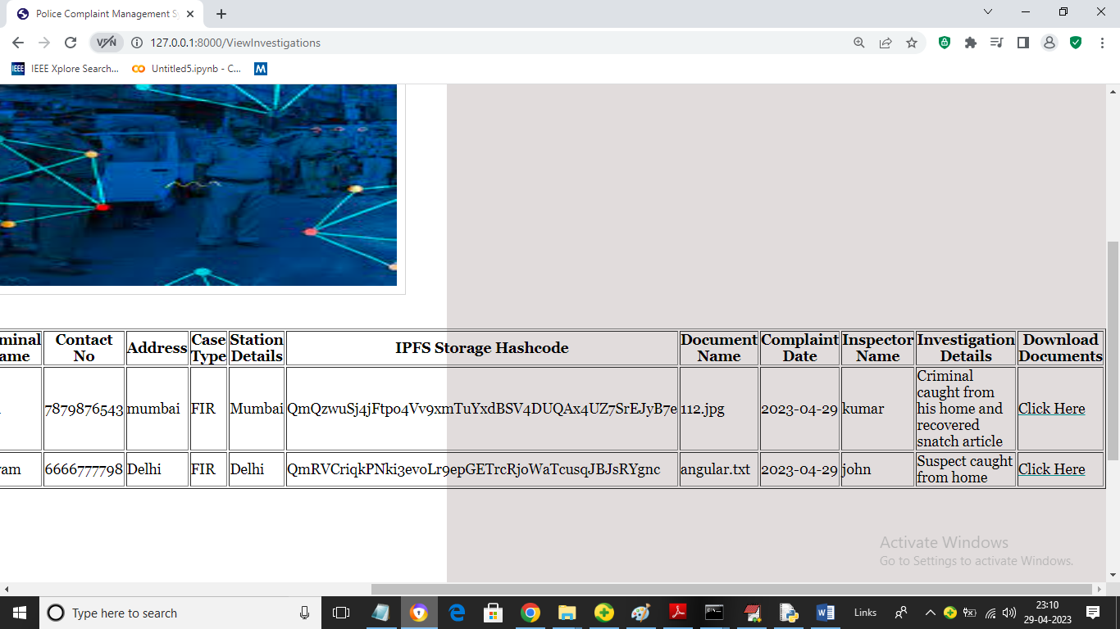

In above screen police can view all crime investigation from Blockchain from anywhere.

Similarly by following above screens you can manage all crime related data in Blockchain